EV Charger
Firmware Architecture Reference
Folder structure, service ownership, and data flow for the STM32-based charger firmware
Practical reference — not a source listing

Contents
Contents 2
1. EV Charger Firmware Architecture 3
2. Architecture Overview 3
3. Recommended Folder Structure 6
4. Folder Responsibilities 6
Core/ 6
Drivers/ 6
BSP/ (Board Support Package) 7
Services/ 7
Application/ 7
Config/ 8
5. Services Architecture 9
6. Application / State Machine 11
Example — what CHARGING actually does 11
7. Important Data Flows 12
7.1 Voltage / Current Measurement 12
7.2 CP Input Path 12
7.3 CP Output / PWM Path 14
7.4 RCM → Safety → Fault Path 15
7.5 Contactor Command + Feedback 15
7.6 RFID → Authorization 16
7.7 Backend Communication 17
8. Main Firmware Execution Flow 19
9. Key Architecture Rules 20
10. Overall Architecture Diagram 21

1. EV Charger Firmware Architecture
This document defines the firmware architecture for the AC (Type 2, Mode 3) EV charger: how the codebase is organized into folders and layers, what each layer and service owns, how data and commands move through the system, and which boundaries the design depends on. It's meant to be used as a working reference while building the STM32 firmware — not as a tutorial and not as a source listing.
Scope: firmware organization, module responsibilities, ownership, and data flow. Detailed pin assignments, ADC channel numbers, and other schematic-dependent specifics are outside this document's scope and are marked TBD where they appear — they depend on the final PCB design.

2. Architecture Overview
The firmware is organized as a strict hierarchy. Commands and configuration flow downward; measurements, status, and feedback flow back upward through the same chain. No layer is allowed to skip over the one directly below it.
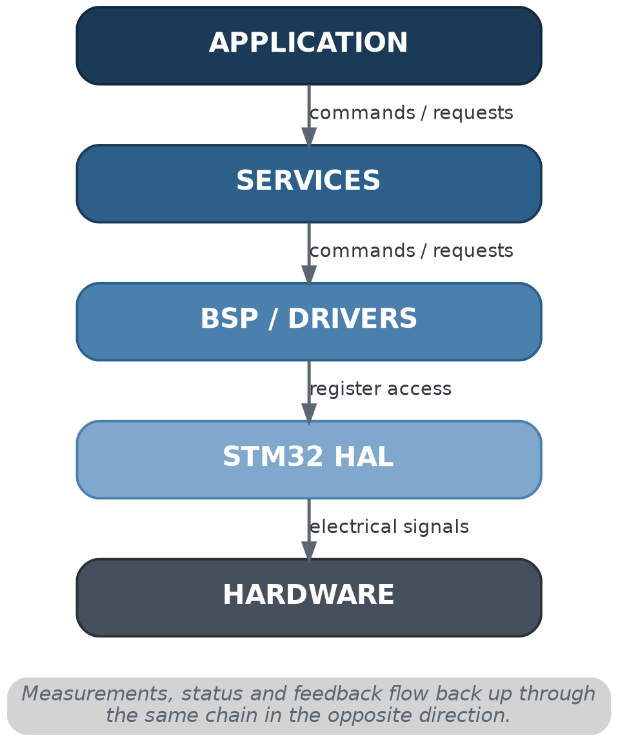
Figure 1. Layer hierarchy — commands flow down, data flows up.
Layer | Answers the question
Application | What should the charger do right now?
Services | How does this particular subsystem behave?
BSP / Drivers | How is this board wired, and how do I talk to this specific device?
STM32 HAL | How do I access this peripheral register?
Hardware | — (the physical world)

ARCHITECTURE RULE
Application decides what the charger should do.
Services determine how a subsystem behaves.
BSP / Drivers determine how hardware is accessed.
Each layer only talks to the layer immediately below it — never skips a layer.

3. Recommended Folder Structure
EV_Charger/
├── Core/ MCU startup, main() entry point
├── Drivers/ Device-level drivers (RFID chip, RCM, display...)
├── BSP/ Board-specific hardware mapping
├── Services/ Subsystem behavior (Safety, CP, Contactor...)
├── Application/Charger-level decisions, the state machine
└── Config/ Centralized configuration & calibration
The same idea, restated as a rule rather than a diagram:
- Core initializes the MCU and hands control to Application.
- Application decides what the charger should do, using Services.
- Services decide how each subsystem behaves, using BSP/Drivers.
- BSP/Drivers decide how hardware is actually accessed, using the STM32 HAL.

4. Folder Responsibilities
Each folder below follows the same structure: purpose, what happens inside, what belongs there, what should not, and which layer it talks to.

Core/
Purpose: Bring the MCU alive, configure peripherals through CubeMX/CubeIDE-generated code, then continuously give the charger firmware CPU time.
What happens inside: main(), HAL_Init(), SystemClock_Config(), peripheral MX_*_Init() calls, and finally a call into the Application layer's init and run functions.
Belongs here: Startup sequencing, peripheral bring-up, and the top-level while(1) loop that hands control onward.
Should NOT belong here: CP state detection, RFID authorization logic, RMS calculation, contactor decision logic, the charging state machine, session management, or fault recovery. If main.c is reading ADCs and making charging decisions in the same function, that logic belongs in Services or Application instead.
Communicates with: Calls down into Application (EVSE_Init() / EVSE_Run()) once startup is complete. Does not talk to Services or Drivers directly.

Drivers/
Purpose: Know how to talk to one specific hardware device — register maps, command sequences, and transfer formats for that part.
What happens inside: Device-specific code, e.g. a PN5180 RFID reader driver: SPI commands, chip registers, initialization sequence, card-detection commands, data-transfer format, device error handling.
Belongs here: Anything specific to the chip itself — functions like Init(), StartDetection(), ReadCredential(), GetStatus().
Should NOT belong here: Any charging-related meaning. A driver should never decide “card detected → check authorization → close contactor.” It only reports what the device told it; higher layers decide what that means.
Communicates with: Called by BSP or by the matching Service (e.g. RFID Service calls the PN5180 driver). Never calls upward into Services or Application.

BSP/ (Board Support Package)
Purpose: Know how this specific PCB wires devices to the MCU — which pin, which timer channel, which ADC channel.
What happens inside: Board-specific mapping code, e.g. bsp_contactor.c, bsp_cp.c, bsp_measurement.c, bsp_led.c — each wrapping a raw HAL/GPIO call behind a named function.
Belongs here: Pin/peripheral mapping and simple hardware access functions (e.g. BSP_Contactor_Set()). This is what makes a PCB revision (e.g. contactor control moving from one pin to another) a one-file change instead of a project-wide find-and-replace.
Should NOT belong here: Interpretation of what a signal means. BSP knows which ADC channel senses CP; it should not decide that the result means “State B.” That belongs in the CP Service.
Communicates with: Sits between Drivers/Services above and the STM32 HAL below. Called by Services; calls into the HAL.

Services/
Purpose: Implement the actual behavior of each charger subsystem — the main functional intelligence of the firmware. See Section 5 for the full breakdown.
What happens inside: One module per subsystem: Safety, Fault, CP, Measurement, Metering, Contactor, Authorization, RFID, Session, Current Limit, Communication, Storage, Diagnostics, Watchdog.
Belongs here: Subsystem logic and the state each subsystem needs to do its job — these are capabilities used across many charger states, not states themselves.
Should NOT belong here: Direct GPIO/register access (that's BSP's job) or charger-level sequencing decisions (that's Application's job).
Communicates with: Called by Application; calls down into BSP/Drivers.

Application/
Purpose: Decide what the charger should do right now, using the information Services provide — without needing to know how any of it is measured or controlled at the hardware level.
What happens inside: evse_app.c, evse_state_machine.c, and a states/ folder with one entry per charger state (initialization, self_test, idle, ev_connected, authorization, charging_preparation, final_safety_check, charging, stopping, session_end, wait_for_unplug, fault).
Belongs here: State transition logic, and orchestration questions like “is CP still requesting energy?”, “any critical safety condition?”, “is the contactor actually closed?”, “has backend requested stop?”
Should NOT belong here: Direct ADC reads, GPIO checks, or register-level work of any kind. If a state handler is calculating RMS or reading a raw PN5180 register, that logic is in the wrong layer.
Communicates with: Calls into Services only. Never calls BSP/Drivers or the HAL directly.

Config/
Purpose: Centralize constants so they're defined once instead of scattered as magic numbers throughout the codebase.
What happens inside: charger_config.h, safety_config.h, cp_config.h, measurement_config.h, timing_config.h — current ratings, voltage/temperature limits, timing thresholds, hardware capability flags.
Belongs here: Configuration (intended product behavior: max current, feature flags, timeout policy) and, if kept separate, calibration (physical correction factors: voltage/current gain and offset, temperature calibration).
Should NOT belong here: Runtime logic of any kind — this folder is data, not behavior.
Communicates with: Read by Services and Application at startup and as needed; not a layer in the command/data hierarchy itself.

5. Services Architecture
Services are capabilities used across many charger states — they are not states themselves. Each owns a specific slice of subsystem behavior and exposes it through a small API.
Service | Owns | Key Inputs | Must NOT do
CP Manager | CP PWM generation, CP measurement/filtering, and A/B/C/D/Fault state detection. | Current limit; CP ADC samples | Decide charger-level meaning of a CP state — that's Application's job
Safety Manager | Continuous evaluation of whether the charger is currently safe to operate (RCM, E-stop, voltage, current, temperature, CP, contactor, measurement freshness). | RCM, E-stop, measurements, CP, contactor status | Classify or latch faults — that's Fault Manager's job
Fault Manager | Recording, classifying, latching and recovering from faults — active/primary/secondary faults, severity, timestamp, history. | Safety Manager output, module-reported faults | Decide whether the charger is currently safe — that's Safety Manager's job
Measurement Manager | Physical measurements — voltage, current, temperature — plus validity and freshness (age) of each value. | Raw ADC samples via BSP | Derive power/energy — that's Metering's job
Metering | Derived quantities: power, energy, charging duration, session/lifetime energy. | Voltage & current measurements | Take its own raw measurements
Contactor Manager | The contactor GPIO — command state, feedback state, open/close timers, failed-to-close / failed-to-open / welded detection. | Open/close requests, aux-contact feedback | Let any other module touch the contactor pin directly
Authorization Manager | Whether this session is permitted to charge — AUTH_PENDING / ACCEPTED / REJECTED / TIMEOUT / ERROR. | RFID credential, backend response, session info | Close the contactor — it only answers authorized or not
RFID Service | Interpreting driver bytes into “a valid credential is available,” independent of the physical reader chip. | Bytes from the reader driver | Decide if the credential is allowed to charge — that's Authorization's job
Session Manager | The lifecycle of one charging session: ID, timestamps, energy, stop reason, status. | Events from Application | Decide where the charger currently is — that's the state machine's job
Current Limit Manager | Arbitrating EVSE max, cable/connector limit, backend limit, site limit, and thermal derating into one advertised current. | Thermal status, backend/site limits, hardware rating | Generate the CP PWM itself — it only decides the number
Communication | External connectivity (Ethernet/Wi-Fi/4G/UART) — receiving remote commands, sending status/session/metering/fault reports. | Backend messages | Control hardware directly (see Section 9 rule)
Storage | Nonvolatile data — calibration, configuration, completed sessions, fault logs, lifetime energy — hiding whether it's internal flash or external EEPROM/flash. | Store/retrieve requests | Expose raw flash-sector operations to higher layers
Diagnostics | Subsystem health reporting — ADC, comms, CP, RFID, RCM, contactor health, sensor validity, reset reason. Used heavily during SELF TEST and field service. | Module health states | Make control decisions
Watchdog | System-health supervision and refreshing the hardware watchdog — conditioned on actual application health, not blindly from an ISR. | Task health status | Refresh unconditionally regardless of application state

IMPORTANT
Safety Manager and Fault Manager are often confused. Safety Manager asks “what unsafe condition exists right now?” Fault Manager asks “how do we record, classify, latch, and recover from that?” They are separate services with separate ownership.

6. Application / State Machine
The Application layer coordinates charger behavior by asking Services meaningful questions — it never reads a register or checks a GPIO itself. The 13-state machine lives here, one handler per state under Application/States/.
Application/
├── evse_app.c / evse_app.h
├── evse_state_machine.c / evse_state_machine.h
└── States/
├── initialization ├── charging_preparation
├── self_test ├── final_safety_check
├── idle ├── charging
├── ev_connected ├── stopping
├── authorization ├── session_end
│ ├── wait_for_unplug
│ └── fault
Power On is more of a system/reset condition than a normal application-state handler.

Example — what CHARGING actually does
While in STATE_CHARGING, the application asks Services meaningful questions and acts on the answers:
- CP Manager — is the EV still requesting energy?
- Safety Manager — any critical safety condition?
- Contactor Manager — is the contactor actually closed?
- Measurement — are measurements healthy?
- Communication — has the backend requested a stop?
- Session — update the session record.
From those answers it decides: continue charging, stop, or fault. That decision — not the underlying measurement — is the state machine's job.

ARCHITECTURE RULE
- Good: CHARGING state asks — “Safety status? CP state? Stop request? Contactor status?” and consumes meaningful information.
- Bad: CHARGING state directly reads an ADC, calculates RMS, checks a GPIO, reads a PN5180 register, or calculates a CP threshold itself.

7. Important Data Flows
Short, concrete paths through the layers for the flows that matter most day to day. Each shows the same pattern: hardware → BSP → Service → whoever consumes the result.

7.1 Voltage / Current Measurement
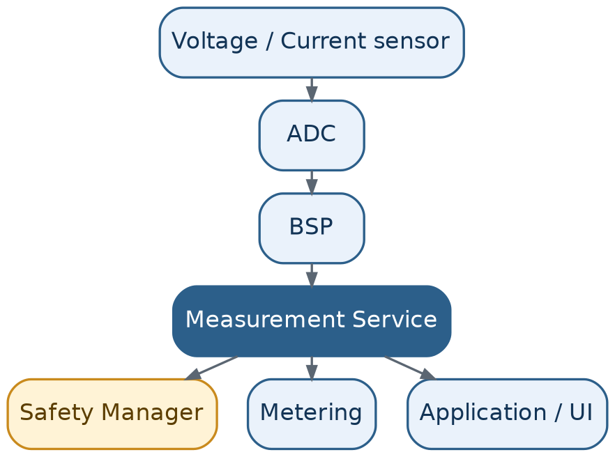
Figure 2. Measurement fans out to every consumer that needs it.
A single measurement is taken once and distributed to every consumer that needs it — Safety Manager for protection, Metering for energy accounting, and Application/UI for display. Each measurement carries a validity flag and an age, so a stale or implausible reading can be caught by Safety Manager rather than silently used.

7.2 CP Input Path
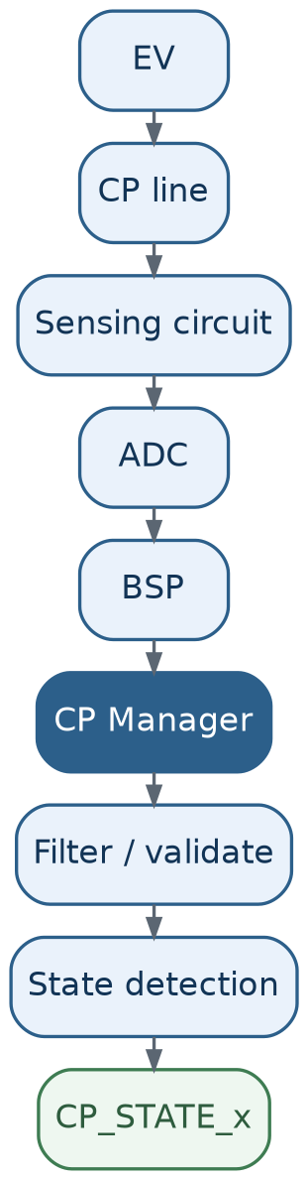
Figure 3. CP input — from the physical line to a named state.
The state machine only ever asks “what is the CP state?” — it never needs to know ADC thresholds or timer registers. All of that interpretation is contained inside the CP Manager.

7.3 CP Output / PWM Path
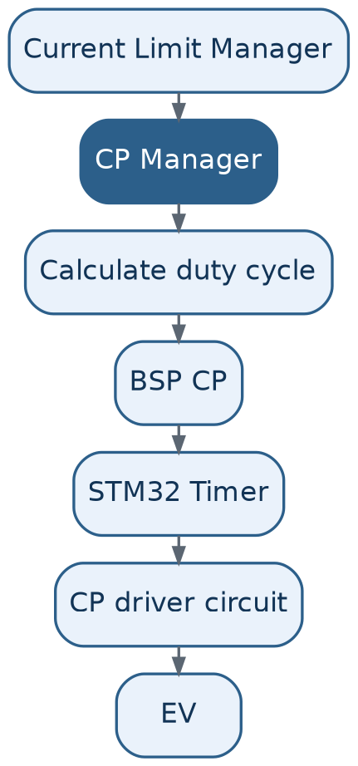
Figure 4. CP output — from an advertised current to a physical duty cycle.
Current-limit policy is deliberately kept out of the CP Manager: Current Limit Manager decides what current should be advertised; CP Manager only knows how to advertise a current once told.

7.4 RCM → Safety → Fault Path
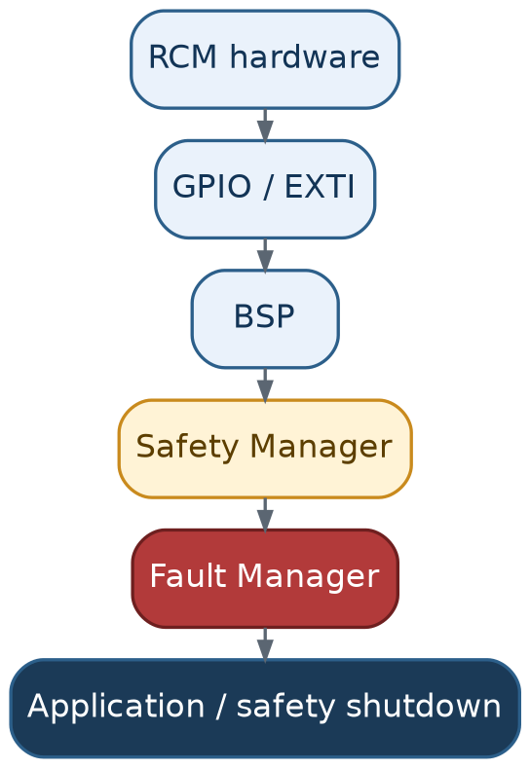
Figure 5. RCM detection through to a safety shutdown.
A physical RCM trip travels through BSP into Safety Manager (which recognizes the unsafe condition) and then Fault Manager (which classifies, latches, and records it) before Application performs a safety shutdown. Note this is firmware's monitoring and response path — it complements, and does not replace, any independent hardware-level disconnect the design requires for RCM-class conditions.

7.5 Contactor Command + Feedback
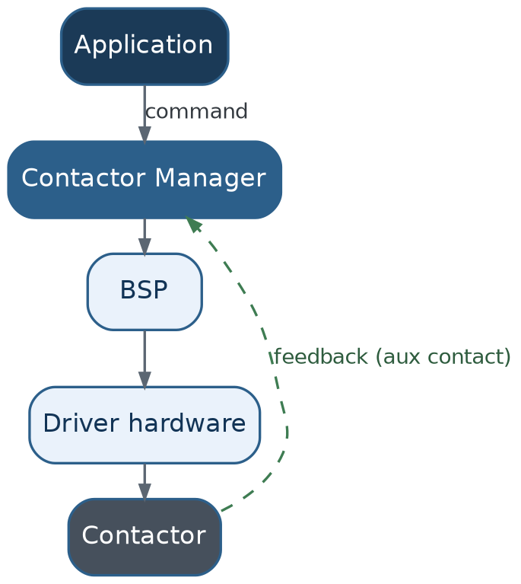
Figure 6. Contactor — command path down, feedback path back up.
The command path and the feedback path are two independent signals, not one assumed-symmetric action. Contactor Manager is the only module that ever issues a command, and it cross-checks every command against the physical aux-contact feedback rather than assuming the command took effect.

7.6 RFID → Authorization
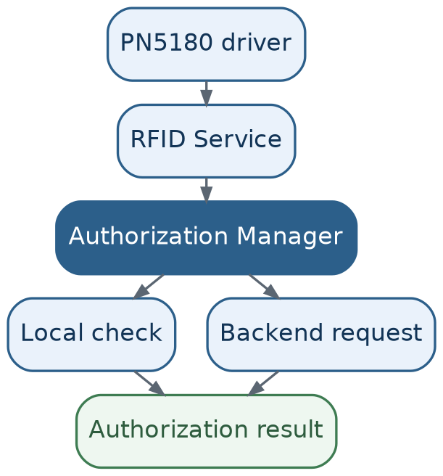
Figure 7. RFID credential through to an authorization result.
Three distinct abstraction levels: the driver reports raw bytes, RFID Service reports “a valid credential is available,” and Authorization Manager is the only one that decides whether that credential is allowed to charge. This separation means the reader hardware can change later without touching authorization logic.

7.7 Backend Communication
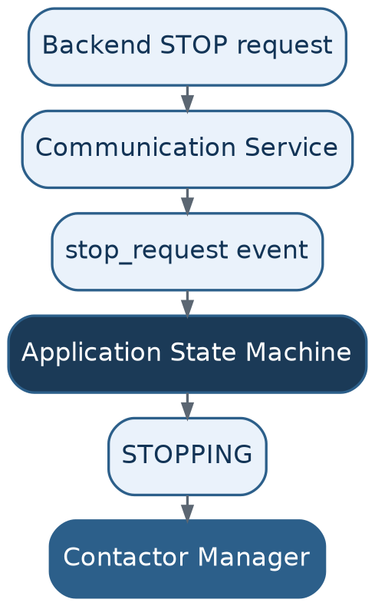
Figure 8. Backend stop request — always through the state machine.
A backend stop request never reaches the contactor directly. Communication Service turns it into an event; Application decides how to act on that event (transition to STOPPING); only then does Contactor Manager act. This preserves the single-owner rule for the contactor regardless of where a stop request originates.

8. Main Firmware Execution Flow
A deterministic, non-blocking super-loop is sufficient for this system. Each pass through the loop services hardware, updates every subsystem, runs one pass of the state machine, updates outputs, and services the watchdog — then repeats.
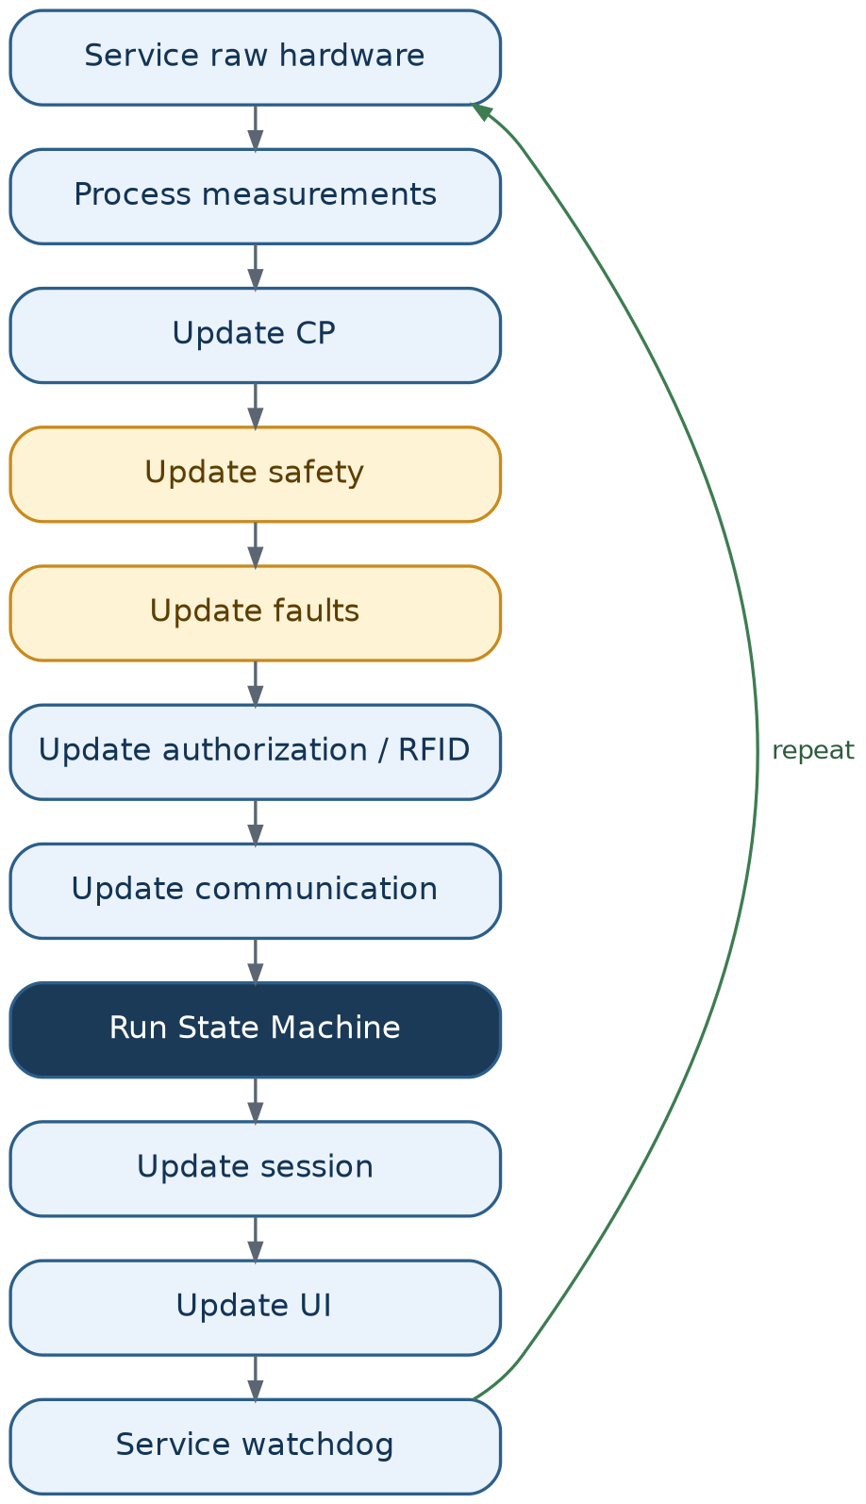
Figure 9. Main loop — one pass, then repeat.
Not every module needs to run its expensive processing on every single iteration — each can have its own period or event schedule (e.g. metering accumulation every cycle, backend telemetry every few seconds). What matters is that no single step blocks the loop waiting on something slow.

9. Key Architecture Rules
A condensed set of rules the rest of this document depends on. These aren't stylistic preferences — each one closes off a specific, easy-to-make mistake.
ARCHITECTURE RULE — Layering & Ownership
Keep main.c minimal — initialize hardware, initialize the application, run the application. Nothing else.
Drivers do not make charger-level decisions; they only report what a device told them.
BSP owns board-specific hardware mapping (which pin, which channel) — nothing above it should care.
Services own subsystem behavior; Application owns charger-level decisions. Neither should do the other's job.
Centralize configuration and calibration in Config/ rather than scattering constants through the code.
Avoid uncontrolled global variables — every piece of state should have exactly one owning module.
Maintain clear data ownership: if two modules can write the same variable, ownership isn't clear yet.

SAFETY CRITICAL
RFID, backend, UI, and communication modules must never directly energize the main contactor — only Contactor Manager writes that pin, and only in response to a request routed through the state machine.
Safety monitoring has priority over normal control, communication, and UI work in every pass of the main loop.
Always verify a contactor command using physical feedback (the aux contact) — never assume a command succeeded.

IMPORTANT — Timing & Execution
Avoid blocking loops and long delays anywhere in the main path — a slow subsystem (backend, RFID, display) must never delay a safety response.
Keep ISRs short: capture data or set a flag, then return. State transitions, communication, and session logic never run in interrupt context.

TBD
Exact pin assignments, ADC channel numbers, and timer/channel mappings referenced as examples in this document (e.g. “contactor on PB5, feedback on PC7”) are illustrative only — the real assignments depend on the finished schematic and belong in BSP once available.

10. Overall Architecture Diagram
The complete picture: Application drives Services, Services drive BSP/Drivers, BSP/Drivers drive the STM32 HAL, and the HAL drives the physical hardware. Measurements, status, faults, and feedback travel back up through the exact same chain, layer by layer — nothing skips a level in either direction.
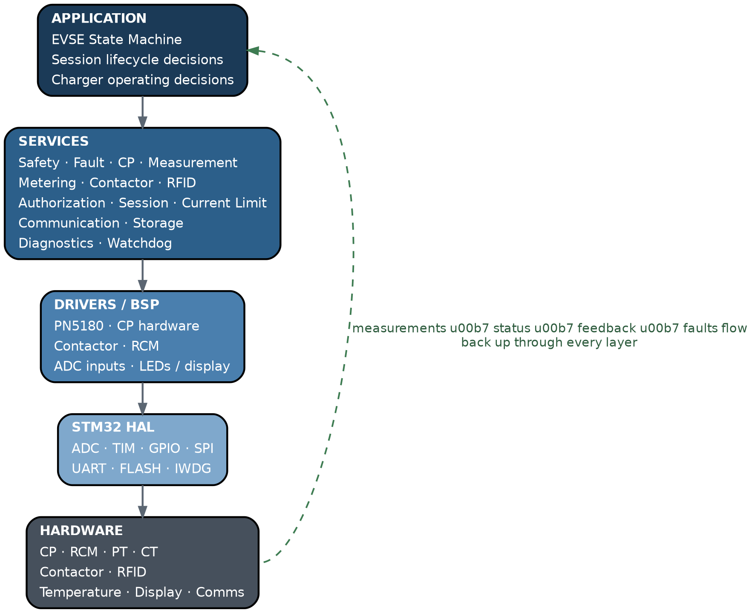
Figure 10. Complete firmware hierarchy, command path down / feedback path up.

ARCHITECTURE RULE — The Four Questions
When implementing any new piece of hardware interaction, answer these in order:
- BSP: “Which physical pin/peripheral is this?”
- Service: “What does this measured/commanded signal mean?”
- Application: “What should the charger do about it?”
- (Config: “What are the limits/thresholds involved?”)
That separation — not any particular file layout — is the actual foundation of this architecture.

